1.- MANAGEMENT SHEETS – Employees

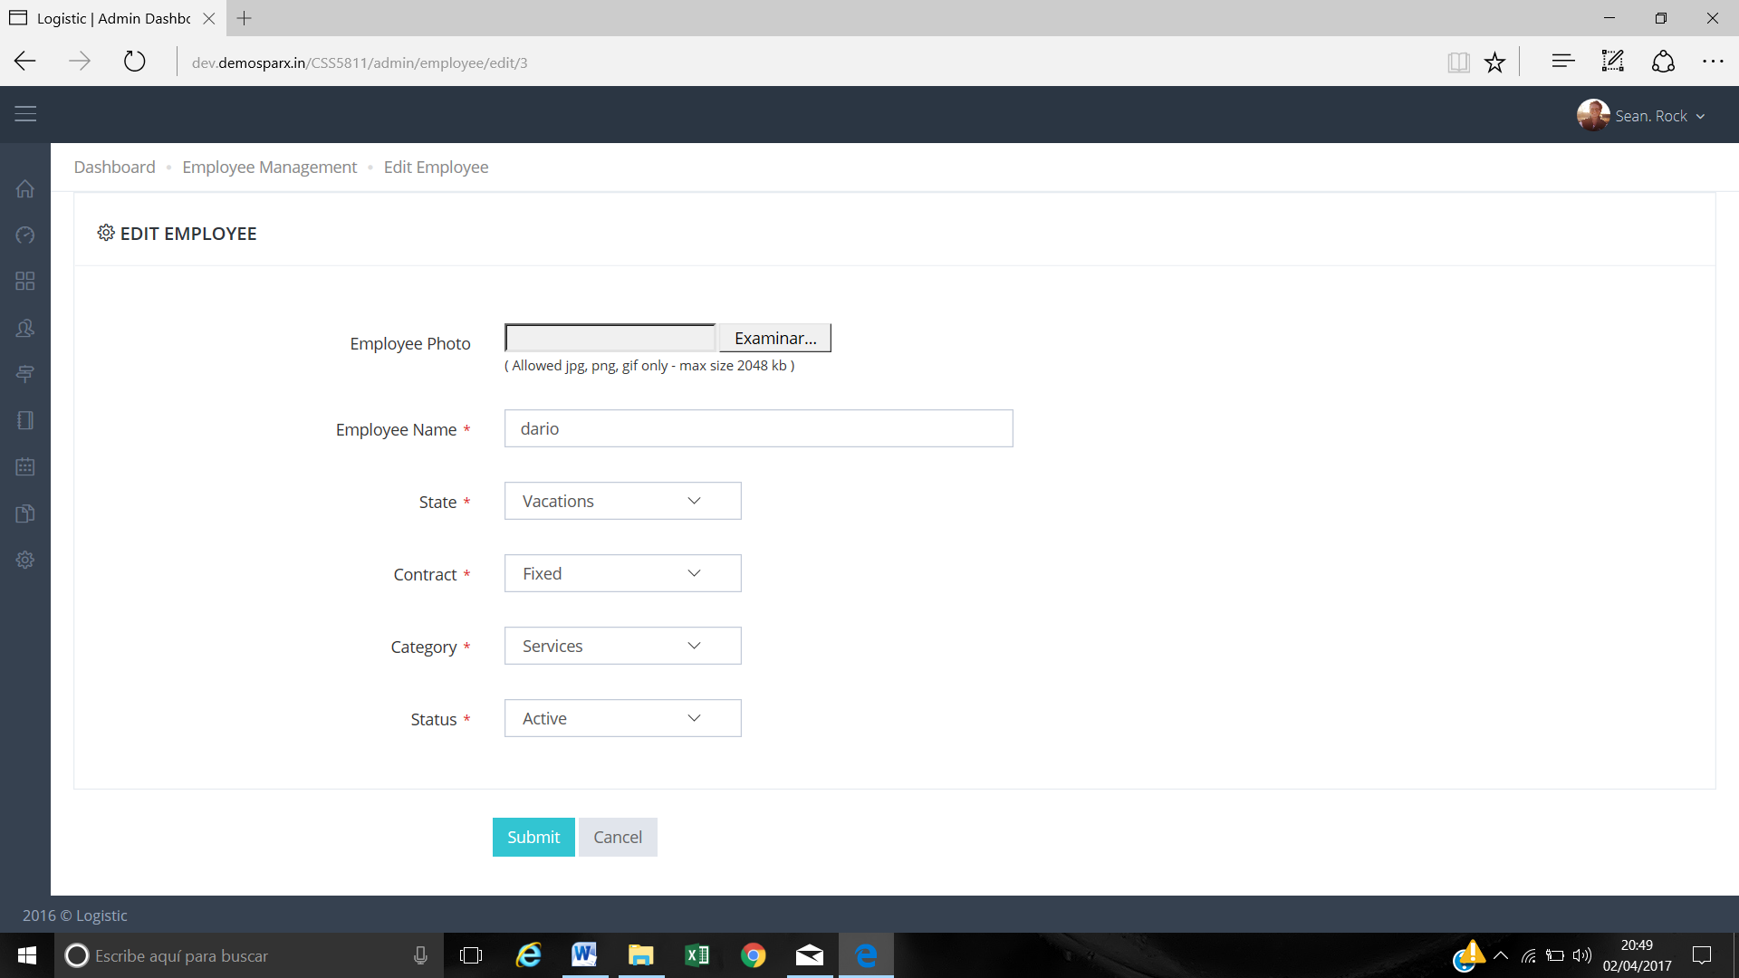

In employee’s management, when editing an employee. In the status, it is necessary to have holidays and lows (absent, on medical leave…) and you have to put a calendar to put that time is the employee of vacations or low.  
When you are on vacation or low is not available at the time of registering a service. Not available.

2.- MANAGEMENT SHEETS – Vehicles

In vehicles management when editing a vehicle if the status of a vehicle is inactive (for example in the workshop or passing a the technical checkups) the period must be marked (inactivity calendar).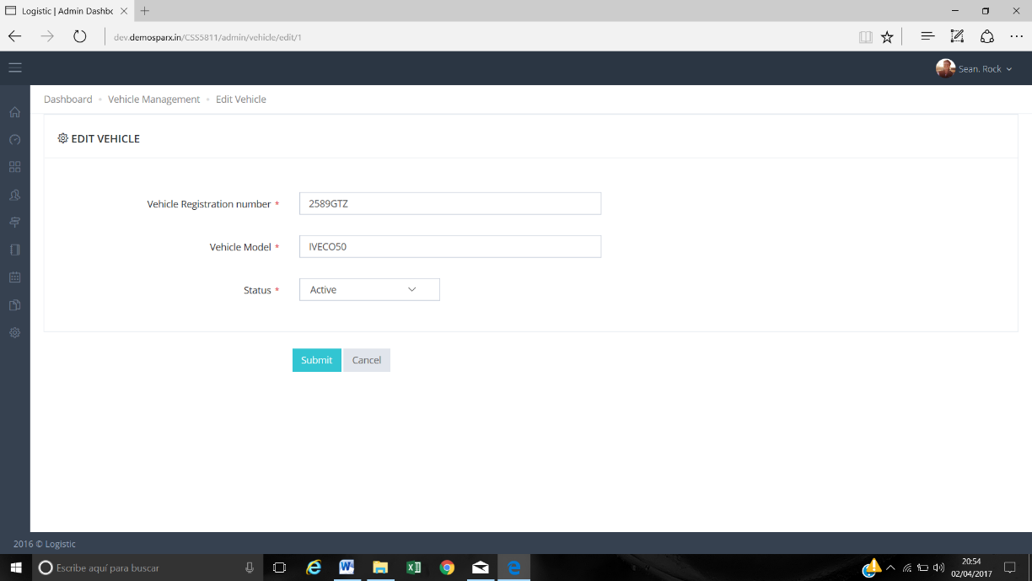

And as in the previous case the vehicle will not be able to select it for a service on those dates.

3.- BOOK SERVICES OR SERVICE SHEET

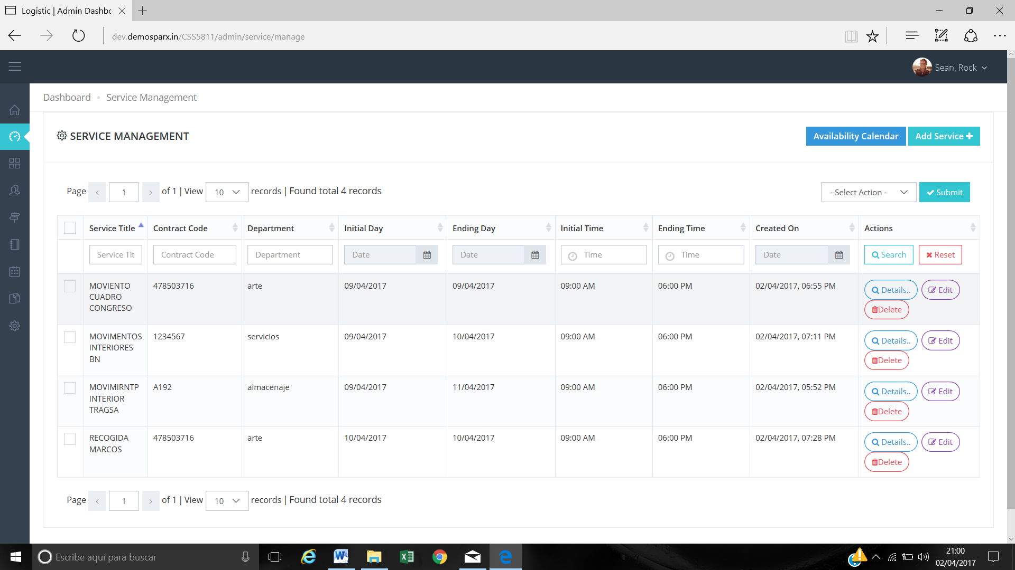

The Customer Name must be included on the screen after the Contrac Code column

**>> Done**

4.- IT IS IMPORTANT

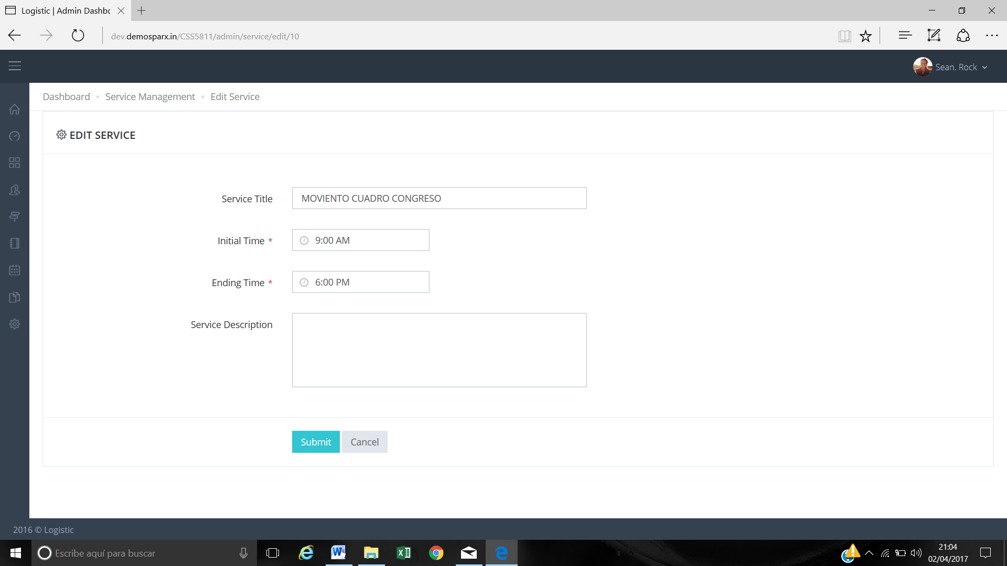

When entering edit service, it is necessary to be able to modify all the fields of the service.

**>> Not Feasible in a current scope, We have think a Feasible design for this, Because a single service has a lot of entries on the daily basis. So that entries cannot be managed in single edit form.**

**Eg. If you create a single service from initial date : 01/04/2017 to ending date : 31/12/2017 and assign 10 employees + 10 vehicles then entries are as following :**

**More than 270 entries : 1 entry for each date with the detail of 10 employees + 10 vehicles.**

**In the initial scope we have disscuss that admin should be able to add/remove resources ( employee, vehicles ) any time for any date on daily basis. So as per requirement it will not feasible to edit all fields in a single edit page.**

**If you need to edit resources follow these steps :**

**1. Open “Book Service”**

**2. Go to listing and click detail button on a service entry. Now you can see all day wise entries for that service.**

**3. For employee : click on “click to see” under “No if employee” column. Now a popup box will open. Here you can add/remove employees for that service.**

**3. For vehicle : click on “click to see” under “No if vehicle” column. Now a popup box will open. Here you can add/remove vehicle for that service.**

5.- THIS IS VERY IMPORTANT

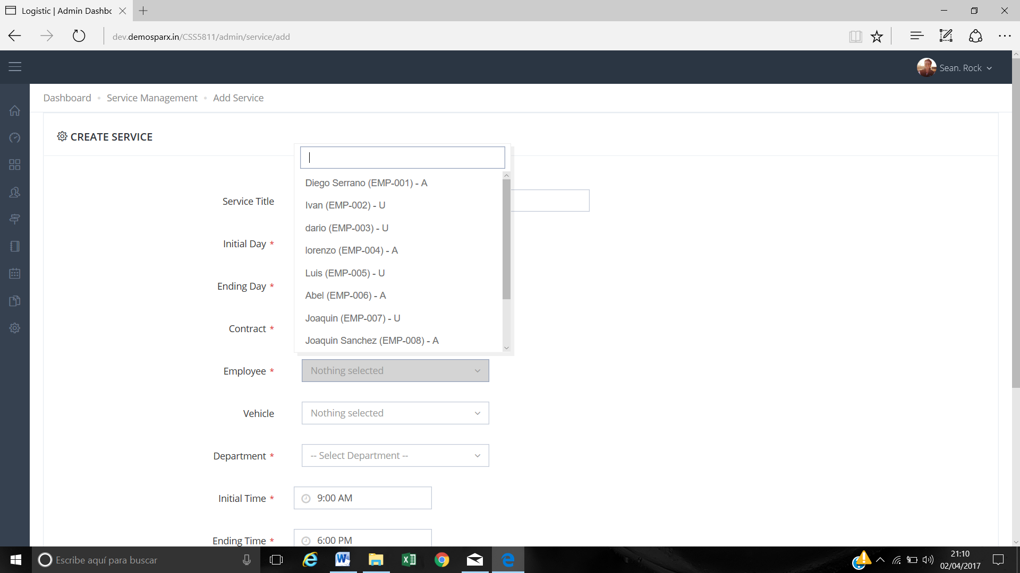

When we register a service and we will assign the employees to it the drop down should only have the STAFF AVAILABLE ON THAT DATE. NOT ALL  
Important: if the service is several days (from 9-04 to 11 -04) the program has to tell me that staff is available EVERY DAY (from 9 to 11 April) and which are available on the 9th, which on the 10th and which day 11th.  
Surely they will have to link to the screen of Availability calendar employees and to show the employees available the days that we are requesting the service of (9 to 11 April).

6.- THIS IS VERY IMPORTANT

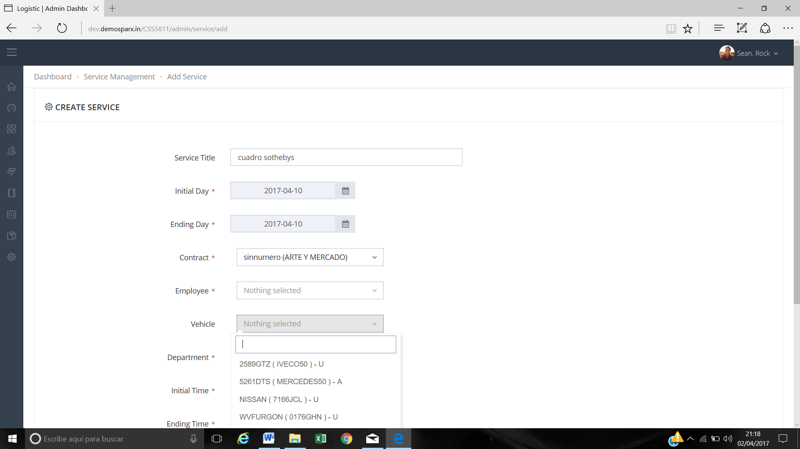

This is the same in case the vehicles should only appear available for the day we are getting the service.  
Important: if the service is several days (from 9-04 to 11 -04) you have to tell me which vehicles are available EVERY DAY (from 9 to 11) and which are available on day 9, which on day 10 and which day eleven.  
They will surely have to link to the screen of Availability calendar vehicles and show the available days on the service (9 to 11).  
In case of being a multi-day service, which are available from (9 to 11 April).

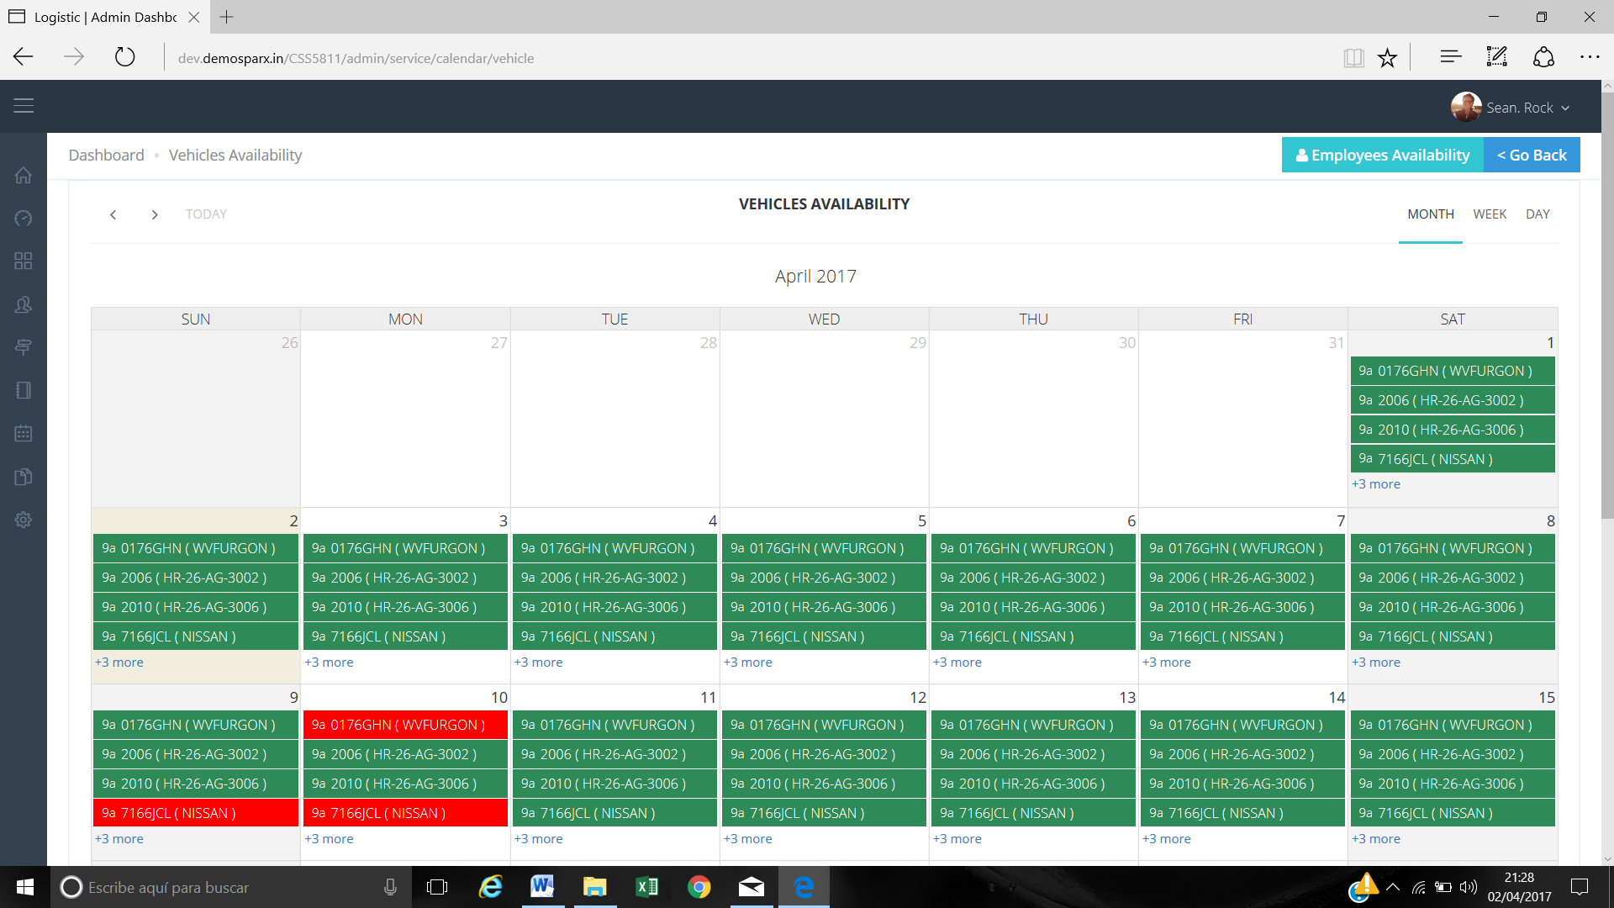

7.- Service Management

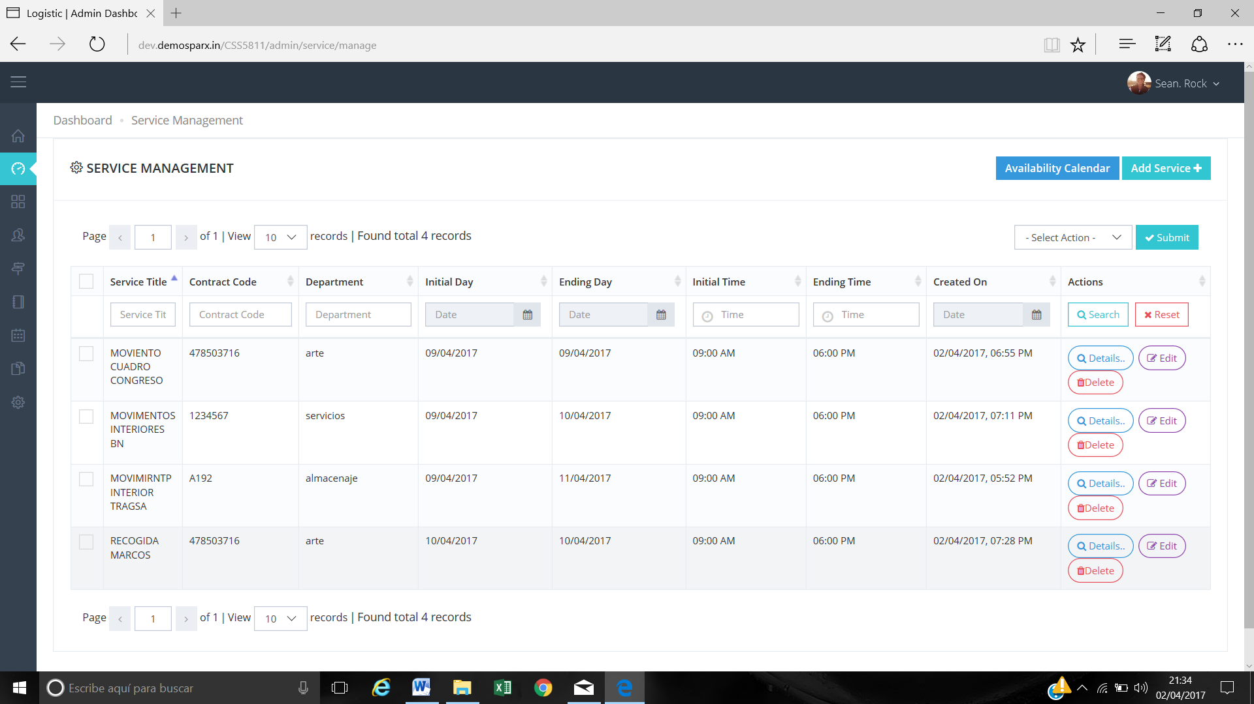

In the example screen, there is service only for day 9, another of 9 to 10, one of 9 to 11 and another only of 10.  
If I select `by date that service there is the day 11 START AND END (that there is one, the third of the screen). DOES NOT GO OUT WHEN YOU DO NOT GET THE DATES OF THE SERVICES THAT LAST MORE THAN ONE DAY.

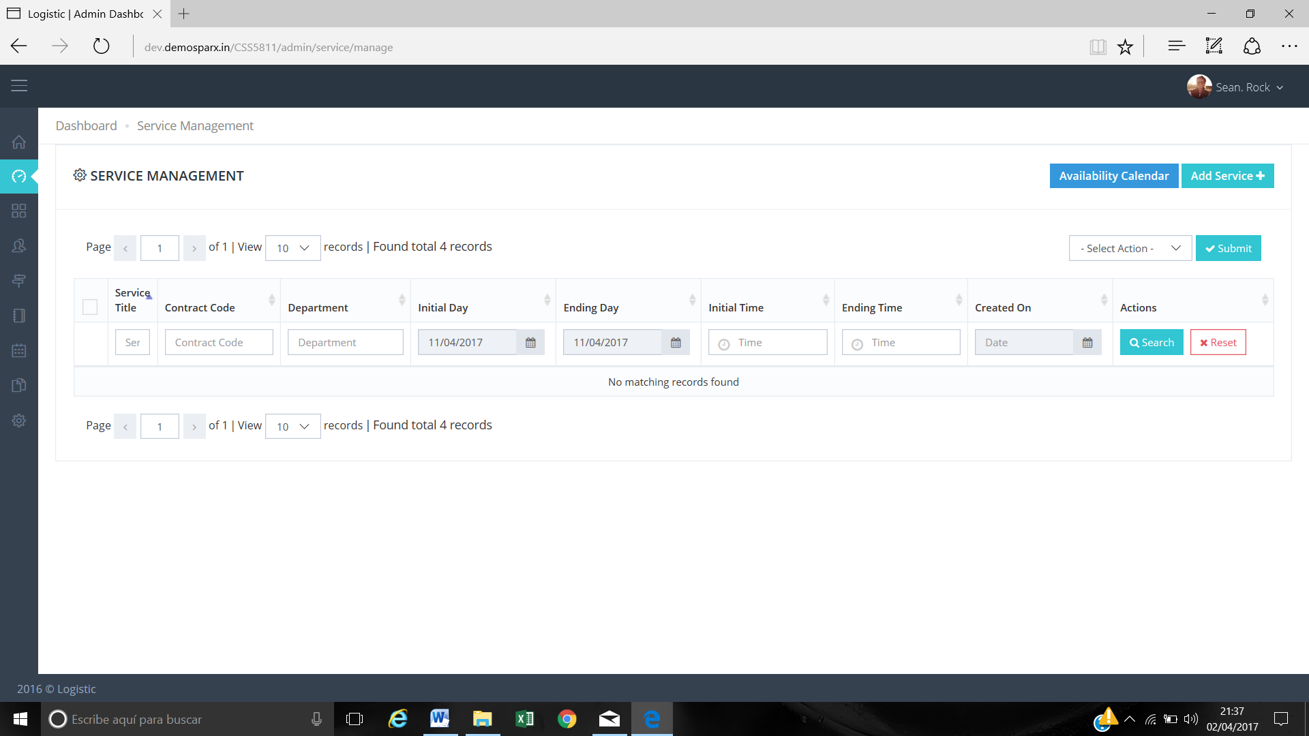

On the other hand, the dates must be European non-American DD / MM / YY. I do not put examples is in the whole application.

8.- Reports.

The diary is fine but you must include the Customer contract, the Contract Title is worthless.

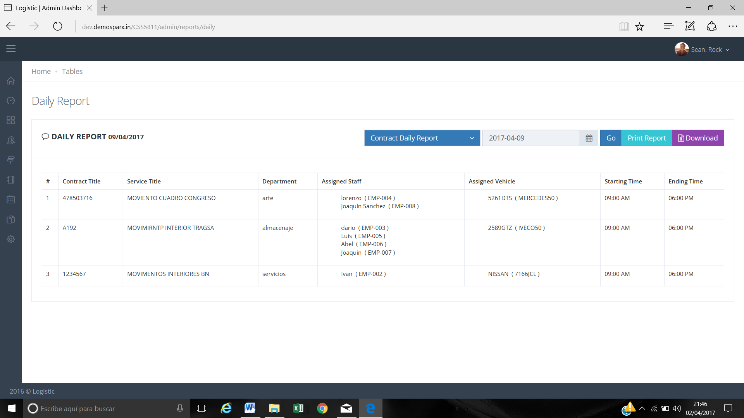

The option to take the report as employee vehicles and contracts is correct.

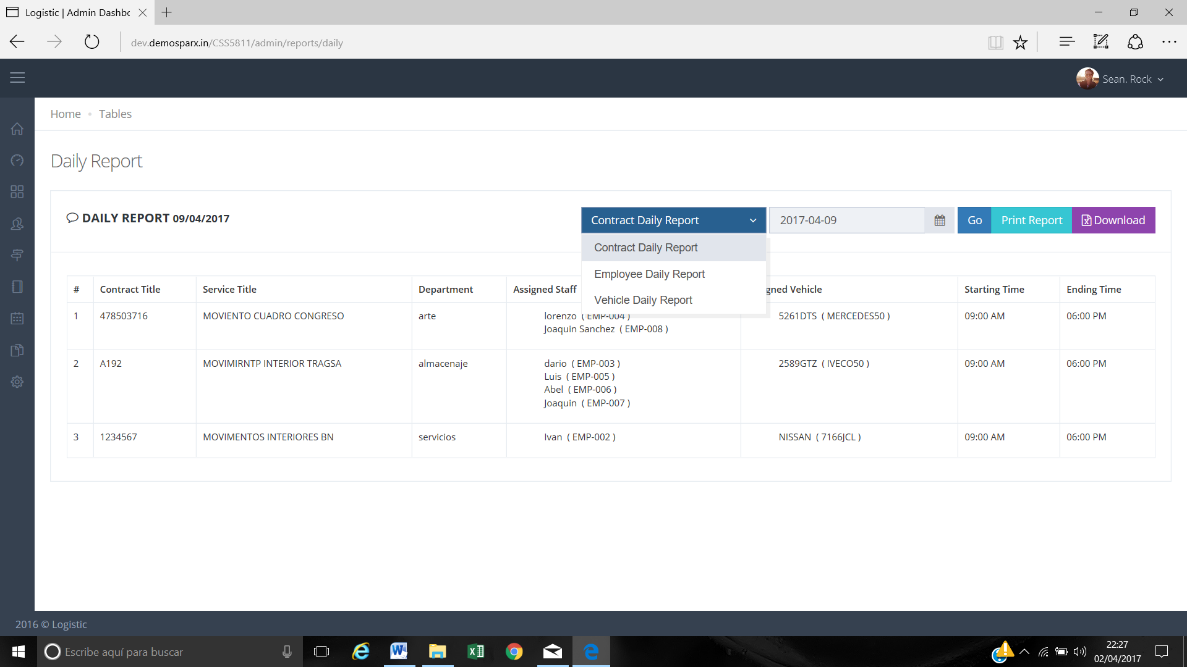

But in the weekly and monthly there is NO OPTION TO TAKE IT OUT BY CONTRACT, only employees and vehicles.

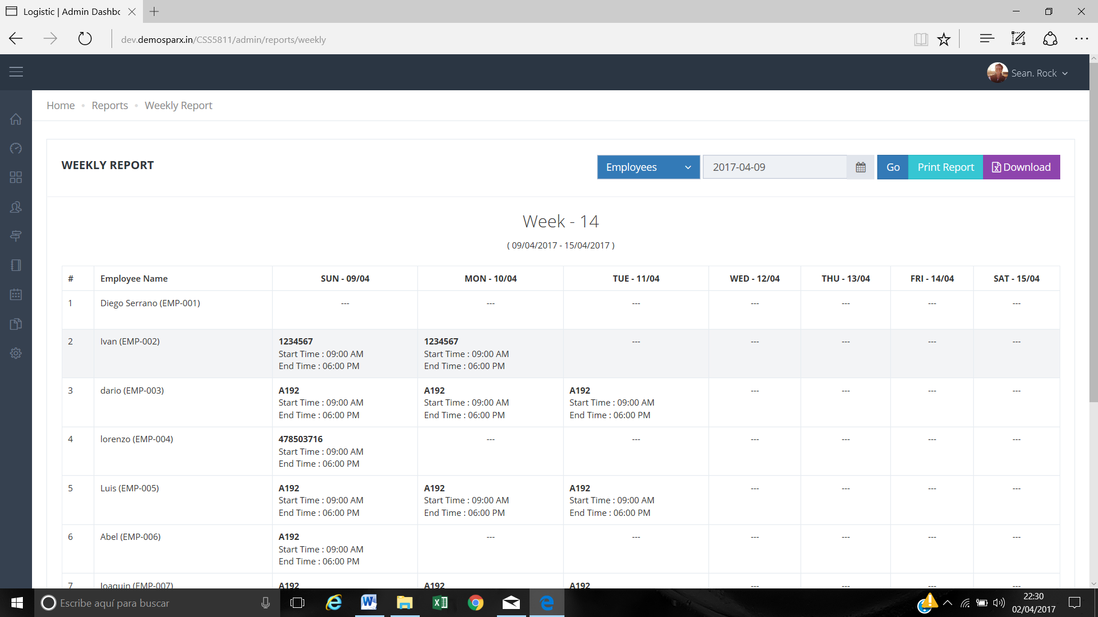

In the weekly and monthly report to quote the service gives the contract title and that does not give information should give the Costumer contract which is what identifies what the service to perform.

9.- In this screen we need to see directly the names of the employees and the vehicles.

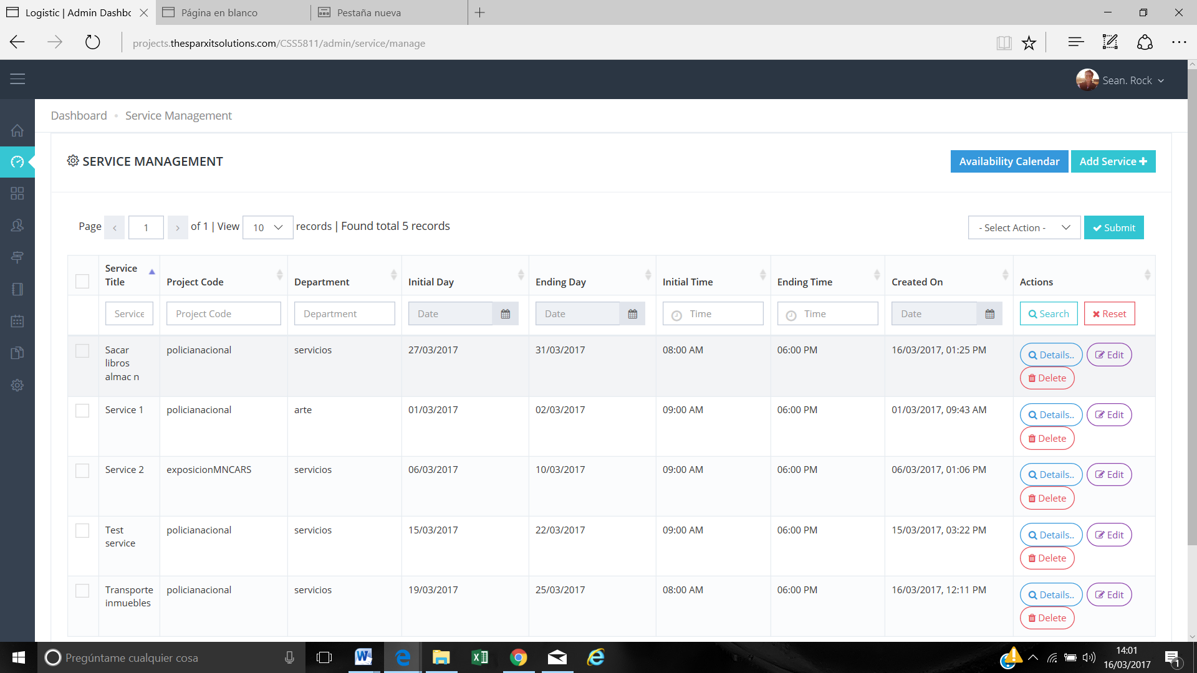

For example we have filtered through one starting day and We cannot see the people and the vehicles assign to this project.

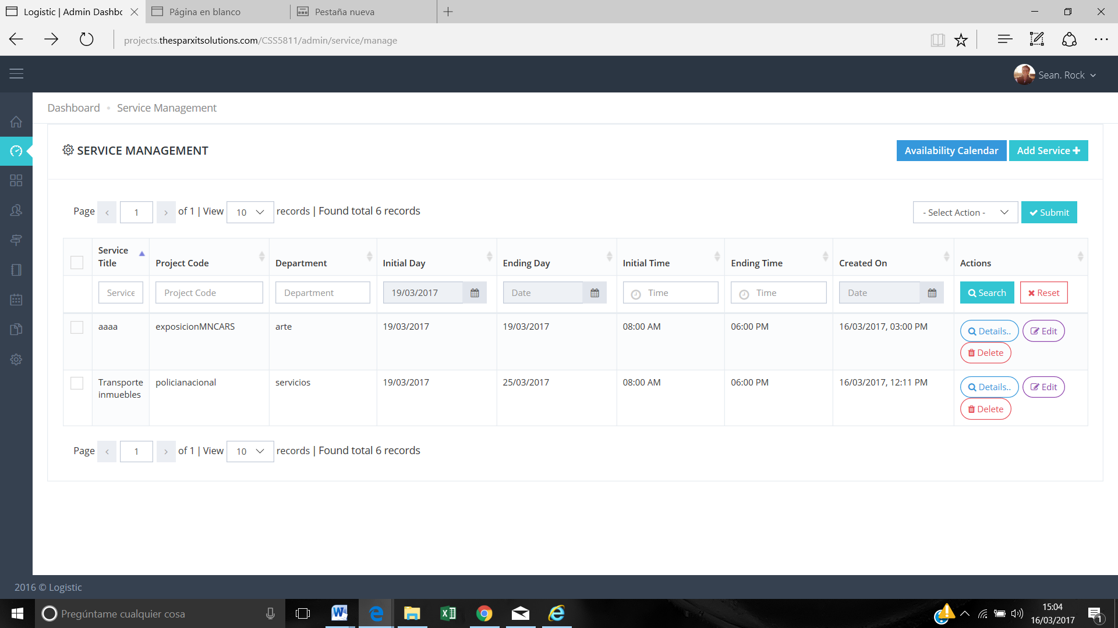

We need to be able to see employee and vehicles without clicking details.

In this screen we want to take out Service Title and Created On and add in this screen Employee and Vehicles assign.

**Reply:** Can you please share the order in which it will be display because each service has multiple entries on daily basis and resources can be modified on daily basis.

For eg. 2 employee / 1 vehicle on 1 Feb and 3 employee / 2 vehicles on 3 Feb. etc.

**Answer:** Maybe we can take out the column “Tittle” and “Created on date” and add Employees and Vehicles.

10.- We need to have the available employees in green and unavailable employees in red. -

**Reply:** CSS does not support for coloring drop-down options, we are trying to find solution for this.

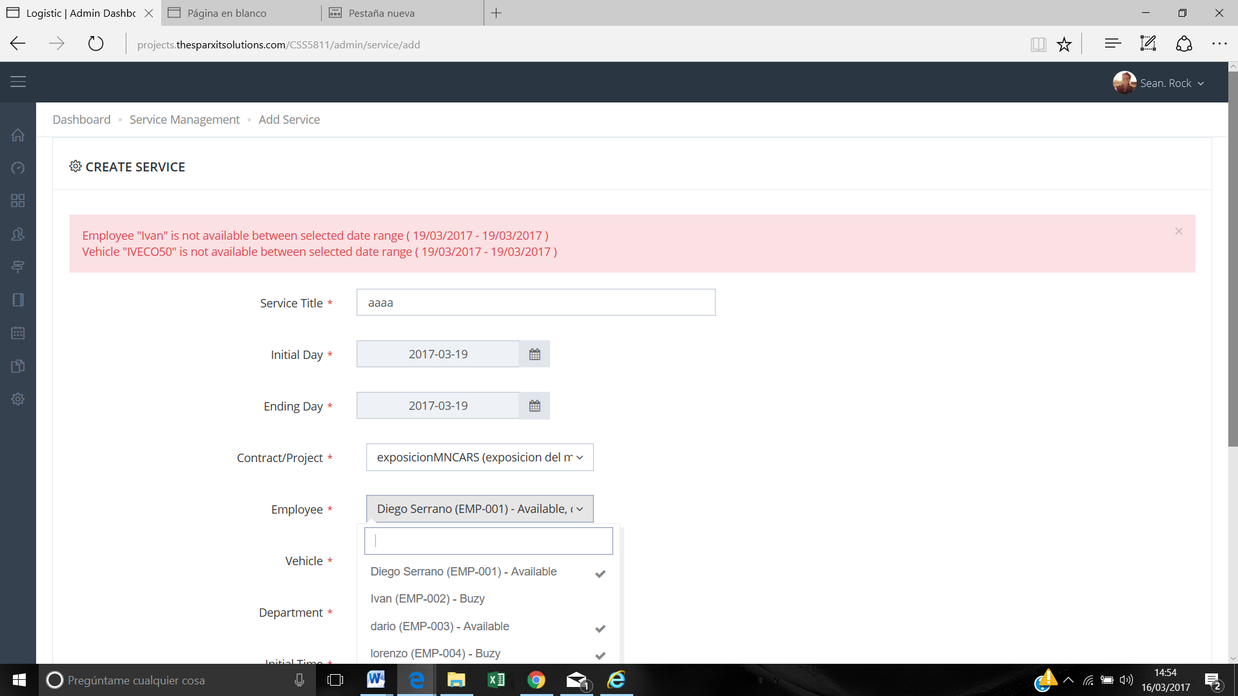

**Answer:** Maybe this point is easier add Available or Unavailable. Show the name and in the right or left part A or U.

11.- Is it possible to add the picture from the employee as well in this picture?

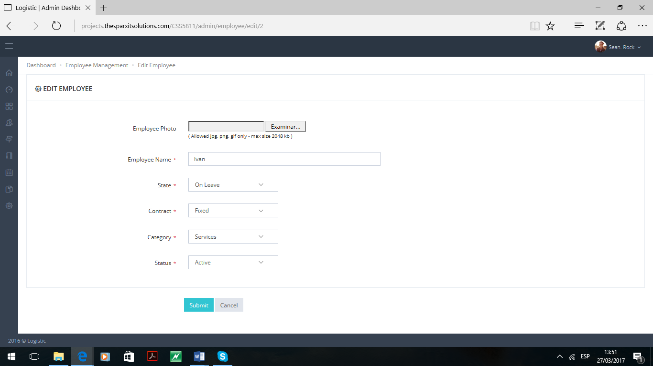

12.- When the user opens to one day it’s not possible to see all the personal and vehicles. We need to see them.

Reply: Done

but we need to change the design

A little bit more pretty

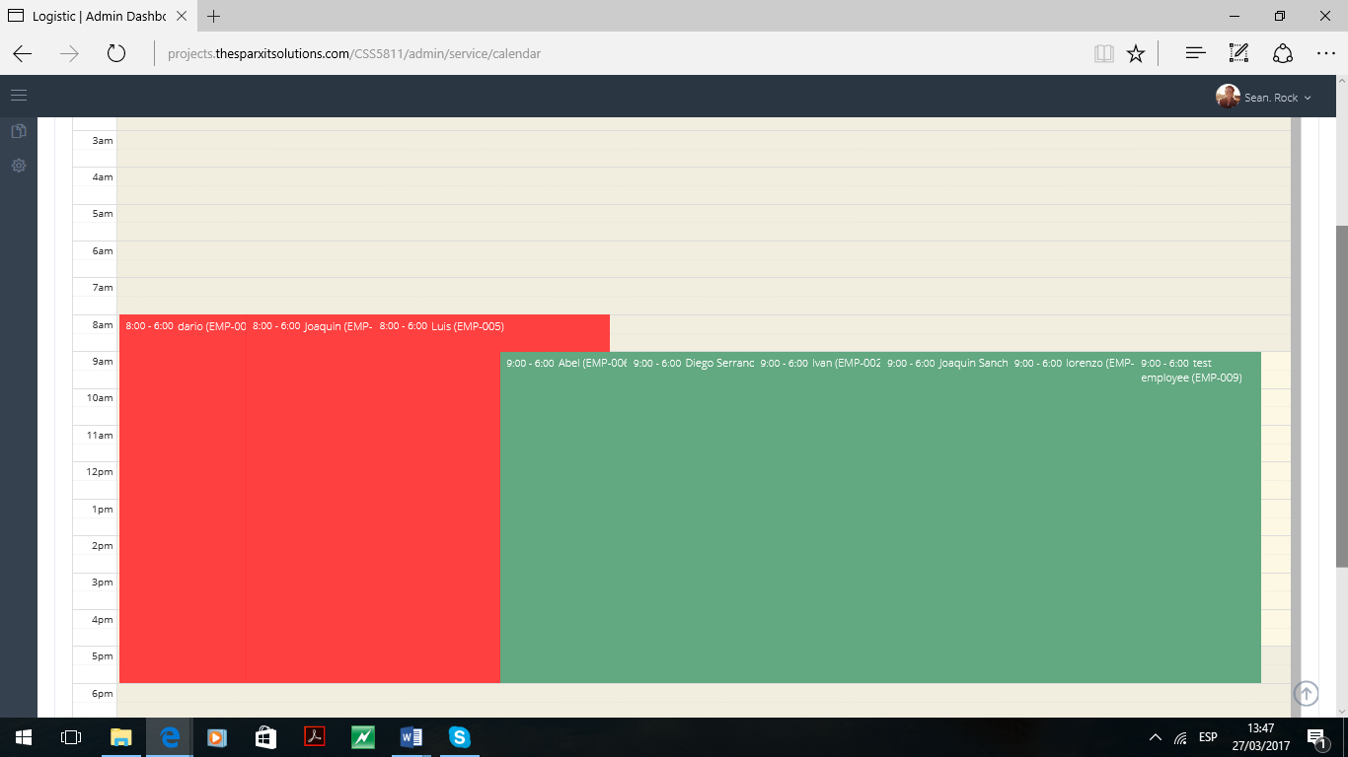

13.- After creating a service the app crashes every time sometimes afterwards the service has been created. But we had to sign up again.

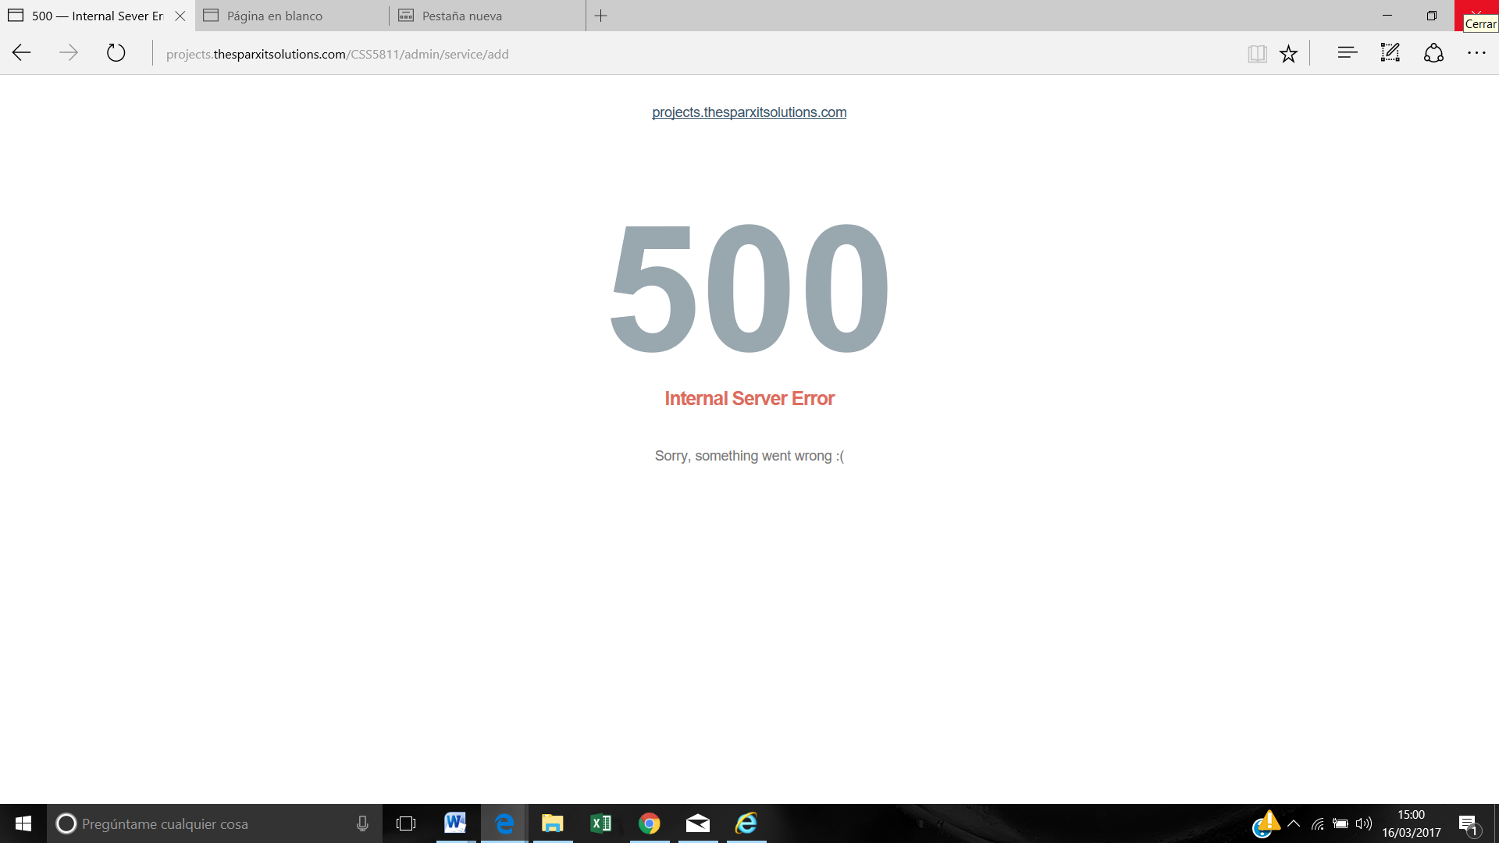

**Reply:** It is server-side internal issue, if you face this issue frequently then let me know we will try to move the project on another server.

**Answer:** we can move it to another server

14.- And we need to translate the screens.